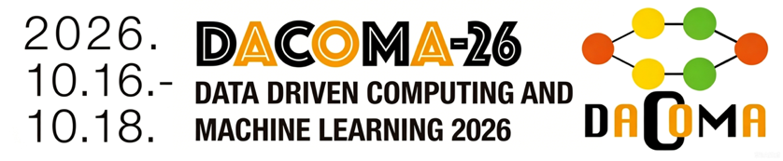

The 6th International Conference on Data-Driven Computing and Machine Learning in Engineering
(DACOMA-26)
Conference Second Announcement
In the age of big data, machine learning technology has been effectively utilized in various fields such as image processing, genomics, engineering computing, macroeconomic forecasting, and medical diagnosis. However, despite its success, applying data-driven computing and machine learning in engineering analytics still presents many unresolved challenges. With the aim of promoting research and the application of big data analysis, data-driven computing, and artificial intelligence in engineering, as well as fostering scientific exchanges among scientists, practitioners and engineers from related disciplines, the International Conference on Data-Driven Computing and Machine Learning in Engineering (DACOMA) has been successfully held since 2019.
The 1st DACOMA, Shanghai, China, 2019.
The 2nd DACOMA, Beijing, China, 2022.
The 3rd DACOMA, Beijing, China, 2023.
The 4th DACOMA, Nanjing, China, 2024.
The 5th DACOMA, Beijing, China, 2025.
The 6th International Conference on Data-Driven Computing and Machine Learning in Engineering (DACOMA-26) will be held in Shanghai, China, 16-18 October, 2026. DACOMA-26 will be guided by the Chinese Society of Theoretical and Applied Mechanics, hosted by Fudan University and Tongji University, and jointly organized by Tsinghua University, Leibniz University Hannover, Bauhaus University Weimar, Beijing Institute of Technology, Hohai University. The conference will be held with Prof. Timon Rabczuk, Prof. Hehua Zhu, and Prof. Zhuo Zhuang, prominent scholars in the field of computational mechanics, serving as the conference chairs. This year's conference will continue to focus on machine learning and AI in general for relevant topics in Engineering and Science.
We sincerely invite experts, colleagues, and students in the fields of data-driven computational mechanics and machine learning to participate in the conference. We are looking forward to seeing you in Shanghai. We believe that you will enjoy the wide variety of activities of the DACOMA-26, as well as your stay in this elegant city.
Conference Chairs
 | 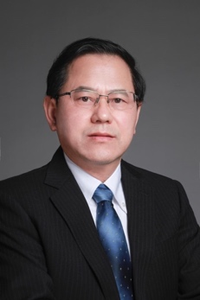 | 
Timon Rabczuk | Hehua Zhu | Zhuo Zhuang
Bauhaus University Weimar/Fudan University | Tongji University | Tsinghua University
Conference Honorary Chair
 | 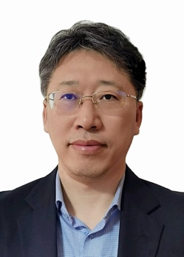
 | Xu Guo
 | Dalian University of Technology
Guidance Unit | Chinese Society of Theoretical and Applied Mechanics
Organizer | Fudan University  Tongji University
Co-Organizer | Tsinghua University  Leibniz University Hannover  Bauhaus University Weimar  Beijing Institute of Technology  Hohai University  Shanghai Society of Theoretical and Applied Mechanics
Chair of Organizing Committee | Xiaoying Zhuang, Zhuo Zhuang
Vice Chair of Organizing Committee | Zhanli Liu, Yanping Lian
Secretary General of Organizing Committee | Yabin Jin, Hongbin Fang
Vice Secretary General of Organizing Committee | Qi Tong, Xinquan Huang, Zheliang Wang
Organizing Committee Member | Zibing Zhang, Zhuojia Fu, Huilong Ren, Jing Xie, Yinan Cui
Conference Venue | Fudan University, 220 Handan Road, Yangpu District, Shanghai, China
Conference Date | 16-18 October, 2026
Conference Website | https://www.dacoma.org.cn
Topics
The topics of DACOMA-26, including but not restricted to
- Engineering Symposium on Engineering Symposium on Frontiers of AI-Empowered Civil Engineering
Organizer: Hehua Zhu, Xiaoying Zhuang
- Data-Driven Computing and Simulating
Organizer: Yanping Lian, Heng Hu
- Digital Twin Modeling and Uncertainty Design
Organizer: Peng Hao, Qi Tong
- Data-Driven Engineering Applications
Organizer: Jian Xiong, Chengwei Fei
- Data-Driven Constitutive Models
Organizer: Shan Tang, Bin Ding
- Machine Learning-Based Solution for Partial Differential Equations
Organizer: Xiaoying Zhuang, Zhuojia Fu
- Machine Learning-Based Metamaterials and Advanced Materials Design
Organizer: Qinglei Zeng, Xiang Li
- Data-Driven Techniques in Multiscale and Multiphysics Simulations
Organizers: Huadong Yong, Jia Li
- Data-Driven Techniques for Continuous and Discrete Methods
Organizers: Dan Huang, Yile Hu
- Data-Driven Design and Optimization
Organizers: Hongling Ye, Zhi Sun
- Visualization and Analysis of Multi-source Data
Organizers: Lei Wang, Jing Xie
- Intelligent Methods for Engineering Systems
Organizers: Yufeng Huang, Hongwei Guo
- AI for Design of Bio-inspired and Bioactive Metamaterials
Organizers: Hui Chen, Bin Li
- Machine Learning Computing for Damage and Fracture Mechanics
Organizers: Yizheng Wang, Jinshuai Bai
- Machine Learning for Inverse Problems and Uncertainty Quantification
Organizers: Xinquan Huang, Yuanyuan Li
- Agentic AI for Mechanics
Organizers: Haifei Zhan, Zheliang Wang
- Data-Driven Computational Methods for Infrastructure Analysis under Uncertainty
Organizers: Yi Luo, Decheng Feng
- Data-Driven Dynamics and Control
Organizers: Hongbin Fang and Shu Zhang
- Physics-Aware Machine Learning for Reduced-Order Modeling
Organizers: Jinlong Fu, Dunhui Xiao

Plenary Talk
 | 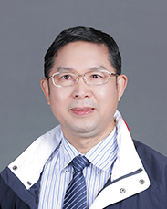 | 
Prof. Zhuo Zhuang  Tsinghua University | Prof. Moubin Liu  Peking University | Prof. Klaus Mainzer  Technical University of Munich, Germany
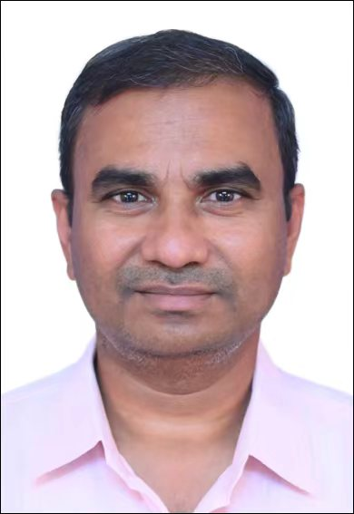 |  | Ongoing update…
Prof. Pattabhi Ramaiah Budarapu  Indian Institute of Technology Bhubaneswar, India | Prof. Nguyen Xuan Hung  VinUniversity, Vietnam

International Scientific Advisory Committee (in alphabetical order by surname)
Klaus Mainzer  （Germany） | Nguyen-Xuan Hung  （Vietnam） | Shaofan Li  （USA） | Wing Kam Liu  （USA）
Peter Wriggers  （Germany） | Weiya Xu  （China） | Yueguang Wei  （China） | Qing Zhang  （China）
Tongyi Zhang  （China） | George Z.H. Zhu  （Canada）

Academic Committee (in alphabetical order by surname)
Chairman: | Zhuo Zhuang | Hehua Zhu | Timon Rabczuk
Members:
C.S. Chen (USA) | Pengwan Chen (China) | Leilei Chen (China) | Wenqi Ding (China)
Chensen Ding (China) | Zongliang Du (China) | Zhuojia Fu (China) | Xiaofan Gou (China)
Jakub Grabski(Poland) | Wanlin Guo (China) | Xu Guo (China) | Klaus Hackl (Germany)
Peng Hao (China) | Yiqian He (China) | Benny Hon (China) | Heng Hu (China)
Weixi Huang (China) | Oun Huang (China) | Xiaomo Jiang (China) | Xiaoning Jiang (USA)
Quang Jiang (China) | Yabin Jin (China) | Qianhua Kan (China) | Gang Li (China)
Xiaojun Li (China) | Yanping Lian (China) | Fang Liu (China) | Yi Liu (China)
Yijun Liu (China) | Zhanli Liu (China) | Xinzheng Lu (China) | Zeng Meng (China)
Juraj Muzik(Slovakia) | Ruiping Niu(China) | Timon Rabczuk(Germany) | Youssef F. Rashed (Egypt)
Huilong Ren (China) | Zhongkui Sun (China) | Sheng Sun(China) | Shan Tang (China)
Shaoqiang Tang (China) | Qi Tong (China) | Cheng Wang (China) | Lihua Wang (China)
Yan Qing Wang(China) | Jun Yan (China) | Bo Yan(China) | Qingsheng Yang (China)
Jie Yang (China) | Hongling Ye (China) | Bo Yu (China) | Yong Yuan (China)
Lihao Zhao (China) | Weisheng Zhang (China) | Xu Zhang (China) | Yiming Zhang (China)
Yufei Zhang (China) | Hehua Zhu (China) | George Z.H. Zhu (Canada) | Xiaoying Zhuang (China)
Zhuo Zhuang (China)

Important Dates
• Abstract Submission Deadline: 20 September, 2026
• Abstract Acceptance Notice: 25 September, 2026
• Early-Bird Registration: Before 31 August, 2026
• Regular Registration: From 31 August, 2026 to 7 October, 2026
• Late and On-Site Registration: After 7 October, 2026
• DACOMA-26 Conference Date: 16-18 October, 2026
Registration
Registration can be implemented through conference website (https://www.dacoma.org.cn) or via Wechat by scanning the QR code below.

Registration Fee
Registration Type | Early-Bird Registration | Regular Registration | Late and On-Site Registration
Full Delegate | 2700CNY / 380USD | 3000 CNY / 420 USD | 3200 CNY / 450 USD
Student Delegate | 1300 CNY / 190 USD | 1500 CNY / 210 USD | 1600 CNY / 230 USD

Payment option
The full payment of registration fee covers: access to all technical sessions, refreshment breaks, lunch & supper, and one copy of the conference material. The registration fee does not include insurance for the participants regarding accidents, sickness or loss of personal property. It is advisable that participants make their own arrangements in respect of health and travel insurance before leaving their countries.

Two payment options are supported in the conference website or Wechat as provided in Registration Section: QR code payment and transfer remittance. For QR code payment or transfer remittance, please be sure to fill in the payment information in the remarks as required below.
QR code:


Transfer information:
Domestic participants are accepted through this account
开户银行: 交通银行上海五角场支行
账号名: 上海会简科技有限公司
账号: 310066690015004049664

Foreign participants are accepted through this account
Name of Bank Account holder: Shanghai Huijian Technology Co., Ltd.
BANK NAME: BANK OF COMMUNICATIONS, SHANGHAI BRANCH YANGPU SUB-BRANCH
Bank Account number: 310066690015004049664
BANK ADDRESS: NO.1317 CHANGYANG ROAD,SHANGHAI CHINA
SWIFT CODE: COMMCNSHSHI
CNAPS: 301290050586
Contact Information: Tel: +86 02160314785
Email: finance@dodoevent.com
Remarks (Mandatory):
For individual transfers: DACOMA + Name+Affiliation
For group transfers: DACOMA + abbreviation of the organization
(The abbreviation shall not exceed 4 Chinese characters. After making a group transfer, please send an email to Jing Li (lijing_fd@fudan.edu.cn) with the subject "DACOMA + organization abbreviation" and the email content including the payer's name + registered mobile phone number+ Affiliation.)

Visa Application
We will provide supporting documents to assist you in obtaining a visa to attend the conference in Shanghai, China. Please send the following information to Dr. Wang (zheliang_wang@fudan.edu.cn)
1. Your full name (as in the passport) and nationality:
2. Your birth date:
3. Passport number, date of issue, and date of expiry:
4. Title of your presentation at the congress and the full name of all the co-authors:
5. Your mailing address:
6. Your affiliated institution/organization:
7. Dates for your visit:

Hotel
*以下酒店为会议主办方合作酒店。参会嘉宾预订客房时请主动告知会议名称，可享受主办方洽谈的协议优惠价。十月为预订旺季，建议尽早预订。
*The hotels below are partner hotels of the conference. Please state the conference name upon reservation to get the agreed preferential rate. October is peak season; please book your room as early as possible.
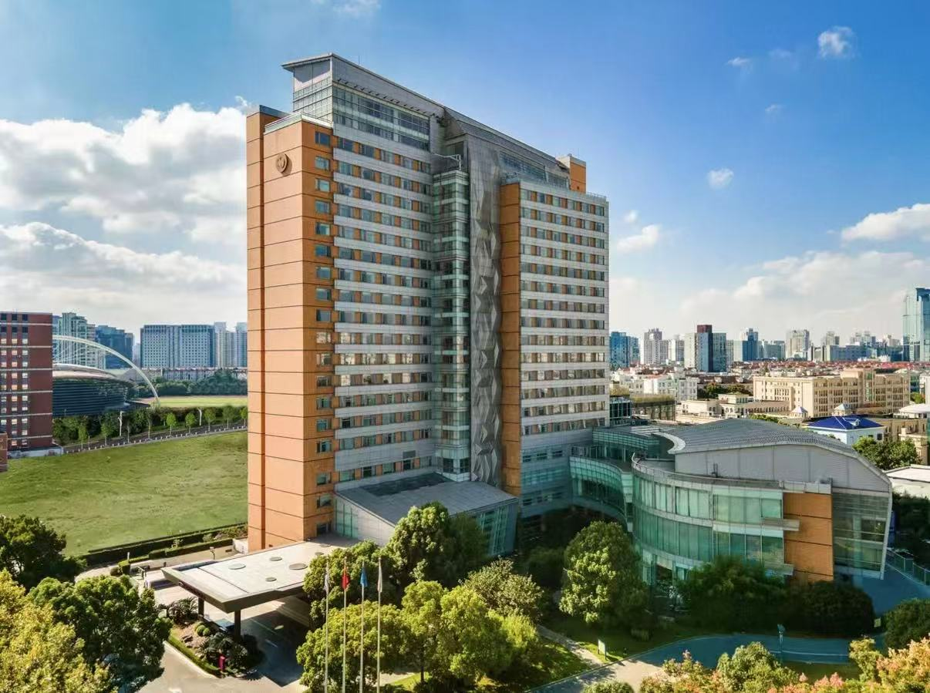
- 上海复旦皇冠假日酒店
地址：上海杨浦区邯郸路199号

Crowne Plaza Shanghai Fudan
Address: 199 Handan Road, Yangpu District, Shanghai

入住信息/Accommodation Standard | 价格/Fee
五星级大床房，房费包含一份免费早餐，双早需另行支付80元  King Room (5-star hotel). Room rate includes one breakfast. An additional breakfast for the second guest costs RMB 80. | 850 CNY
预订方式：请联系酒店黄经理（电话：13701884247），预订时请告知会议全称：第六届工程数据驱动计算与机器学习国际会议（DACOMA 2026）
Booking information: Please contact Manager Huang at the hotel, Tel: 13701884247. Kindly mention the conference name The 6th International Conference on Data-Driven Computing and Machine Learning 2026 (DACOMA 2026) when making reservations.


- 上海中谷小南国花园酒店
地址：上海杨浦区佳木斯路777号
Shanghai Nakou Little South China Garden Hotel
Address: 777 Jiamusi Road, Yangpu District, Shanghai

入住信息/Accommodation Standard | 价格/Fee
湖景大床房，房费包含免费单早及双早  Lake View King Room. The rate includes complimentary single breakfast / double breakfast. | 500 CNY
预订方式：请致电021-25258888转预订部，预订时请告知会议全称：第六届工程数据驱动计算与机器学习国际会议（DACOMA 2026）
Booking information: Please call 021-25258888 and ask for the Reservations Department. Kindly mention the conference name The 6th International Conference on Data-Driven Computing and Machine Learning 2026 (DACOMA 2026) when making reservations.

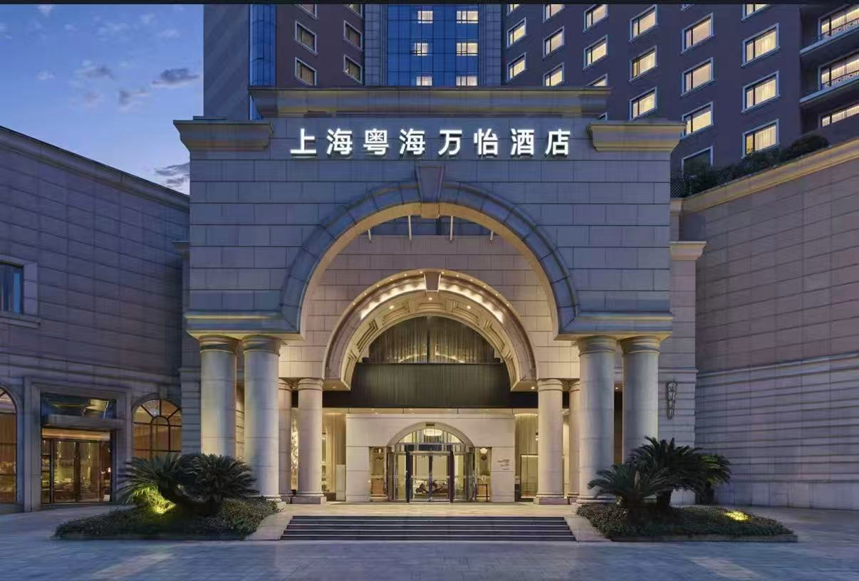
- 上海粤海万怡酒店
地址：上海虹口区逸仙路328号
Courtyard by Marriott Shanghai Yuehai
Address: 328 Yixian Road, Hongkou District, Shanghai

入住信息/Accommodation Standard | 价格/Fee
四星级房型将根据酒店实际房态进行安排  Room types of the 4-star hotel will be arranged subject to actual room availability of the hotel. | 500 CNY including one breakfast; 560 CNY including two breakfasts.
预订方式：请联系酒店彭经理13816385289，预订时请告知会议全称：第六届工程数据驱动计算与机器学习国际会议（DACOMA 2026）
Booking information: Please contact Manager Peng at the hotel, Tel: 13816385289. Kindly mention the conference name The 6th International Conference on Data-Driven Computing and Machine Learning 2026 (DACOMA 2026) when making reservations.

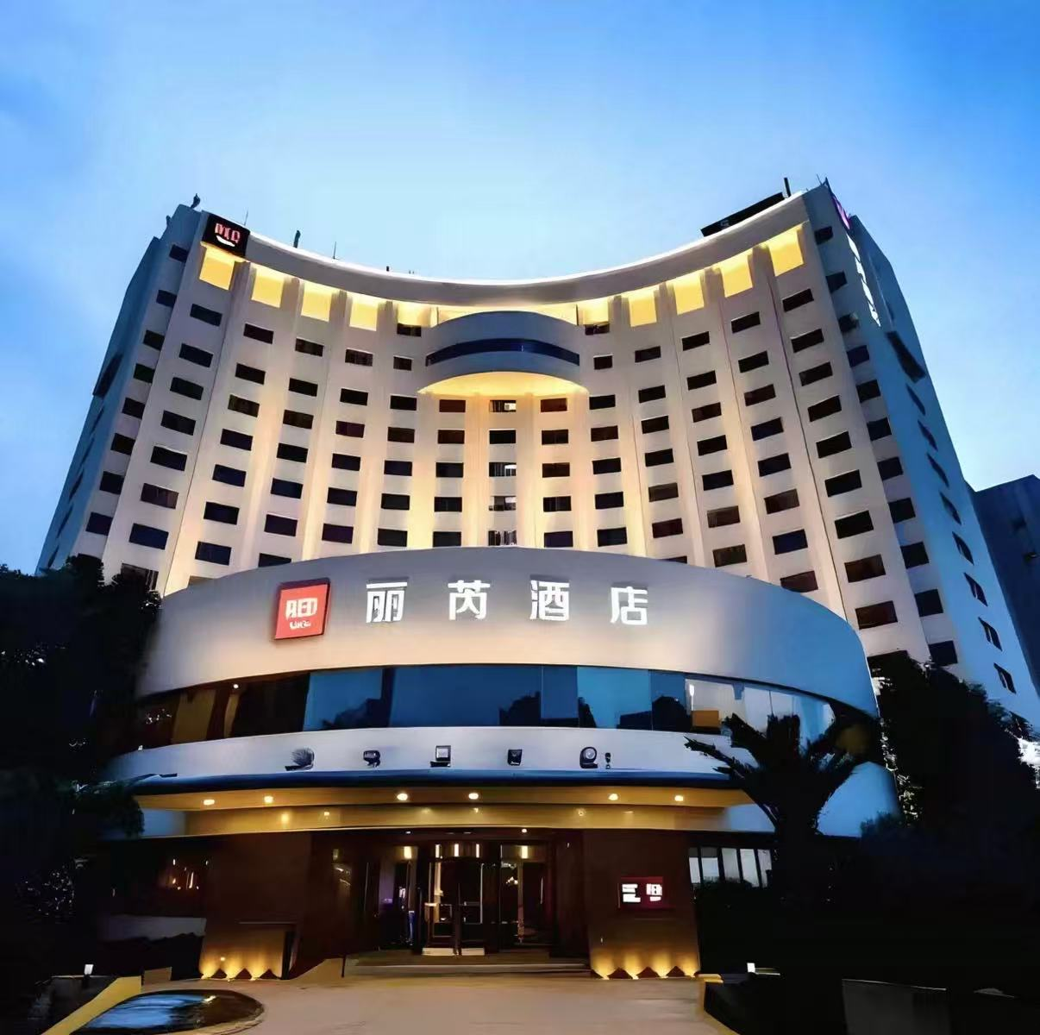
- 上海五角场丽芮酒店
地址：上海杨浦区四平路1251号

Radisson RED Shanghai Wujiaochang
Address: 1251 Siping Road, Yangpu District, Shanghai

入住信息/Accommodation Standard | 价格/Fee
四星级标间  4-star Twin Room | 500 CNY including one breakfast; 550 CNY including two breakfasts.
预订方式：请联系酒店孙经理17701878754，预订时请告知会议全称：第六届工程数据驱动计算与机器学习国际会议（DACOMA 2026）
Booking information: Please contact Manager Sun at the hotel, Tel:17701878754. Kindly mention the conference name The 6th International Conference on Data-Driven Computing and Machine Learning 2026 (DACOMA 2026) when making reservations.

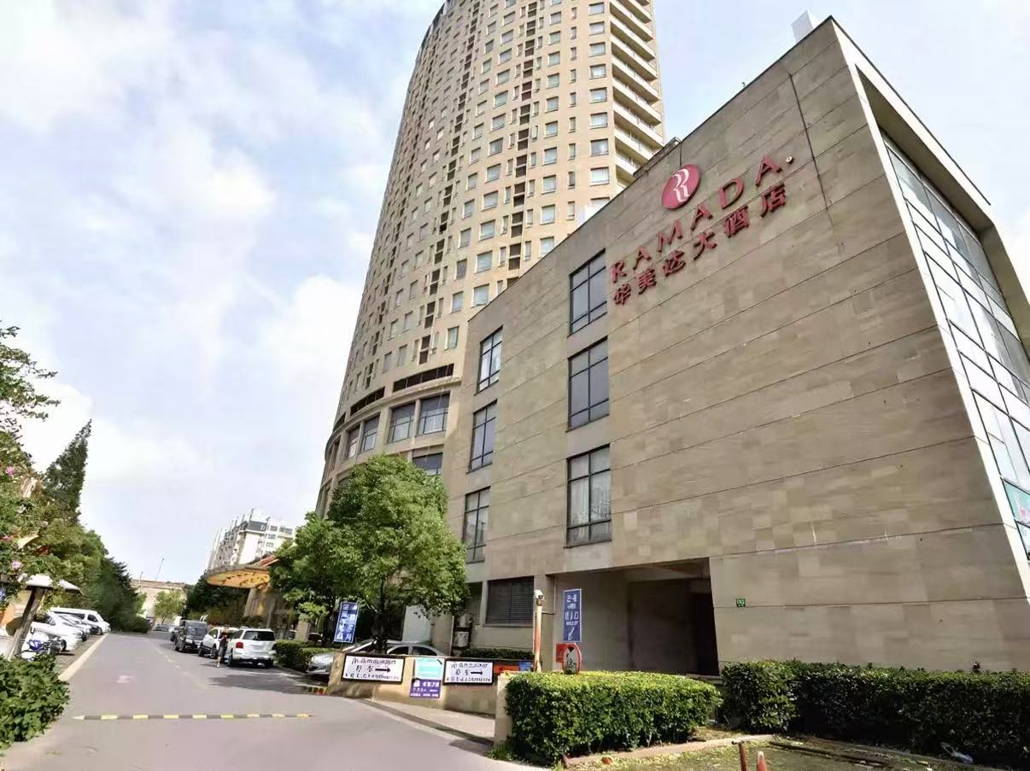
- 上海五角场华美达大酒店
地址：上海杨浦区黄兴路1888号
Ramada by Wyndham Wujiaochang Shanghai
Address: 1888 Huangxing Road, Yangpu District, Shanghai
入住信息/Accommodation Standard | 价格/Fee
四星级标间，房费包含免费单早及双早  4-star Twin Room. The rate includes complimentary single breakfast / double breakfast. | 360 CNY
预订方式：请联系酒店张经理13671846388，预订时请告知会议全称：第六届工程数据驱动计算与机器学习国际会议（DACOMA 2026）
Booking information: Please contact Manager Zhang at the hotel, Tel:13671846388. Kindly mention the conference name The 6th International Conference on Data-Driven Computing and Machine Learning 2026 (DACOMA 2026) when making reservations.

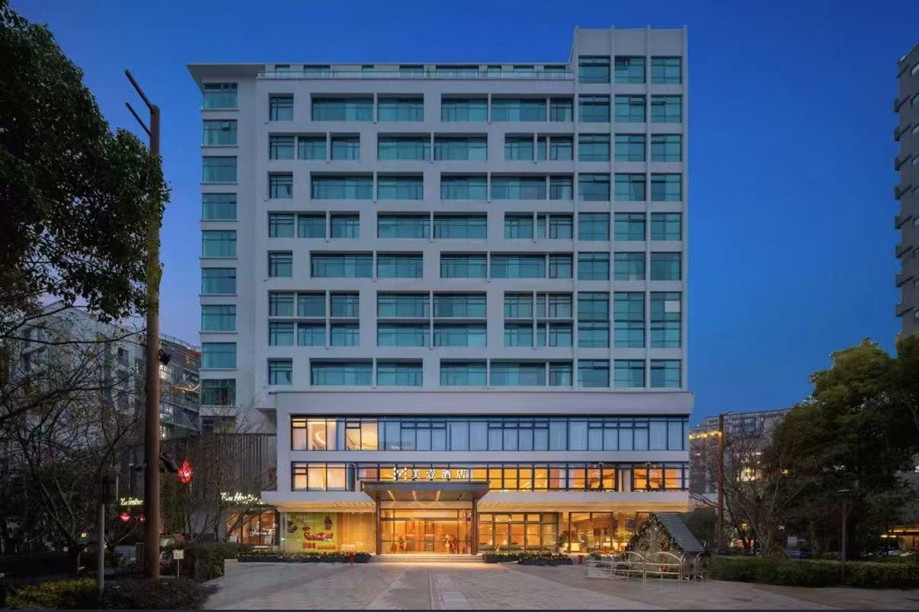
- 上海五角场大学路美壹酒店
地址：上海杨浦区伟德路6号
MOne Hotel Shanghai Wujiaochang
Address: No.6 Weide Road, Yangpu District, Shanghai
入住信息/Accommodation Standard | 价格/Fee
高级双人间  Superior Twin Room (includes two breakfasts)  豪华双人间  Deluxe Twin Room (includes two breakfasts) | 580 CNY  600 CNY
预订方式：请联系酒店吉经理13816222874，预订时请告知会议全称：第六届工程数据驱动计算与机器学习国际会议（DACOMA 2026）
Booking information: Please contact Manager Ji at the hotel, Tel:13816222874. Kindly mention the conference name The 6th International Conference on Data-Driven Computing and Machine Learning 2026 (DACOMA 2026) when making reservations.

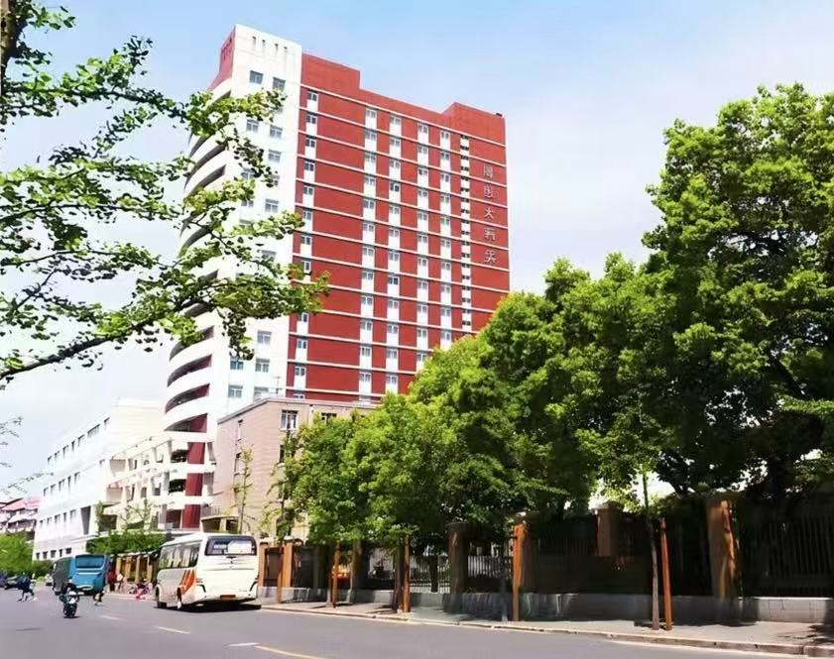
- 上海博思大酒店
地址：上海虹口区广秀路 100 号
Shanghai Boss Hotel
Address: 100 Guangxiu Road, Hongkou District, Shanghai
入住信息/Accommodation Standard | 价格/Fee
四星级标间，房费包含免费单早及双早  4-star Twin Room. The rate includes complimentary single breakfast / double breakfast. | 400 CNY
预订方式：请致电021-25099999，预订时请告知会议全称：第六届工程数据驱动计算与机器学习国际会议（DACOMA 2026）
Booking information: Please call 021-25099999. Kindly mention the conference name The 6th International Conference on Data-Driven Computing and Machine Learning 2026 (DACOMA 2026) when making reservations.

Attachment
Paper Title (14 Pt Arial, Bold, Centered)

Author name¹, Author name^{2,*}, Author name³, and Author name⁴

¹ Institute of Computational Mechanics × AI & College of Intelligent Robotics and Advanced Manufacturing, Fudan University, Shanghai 200433, China

² Affiliation, address

³Affiliation, address

⁴Affiliation, address

*Corresponding author’s email: dacoma2026-XXX@Fudan.edu.cn

ABSTRACT
All abstracts and papers must be presented in English, should not exceed 500 words, and must fit on this single page along with the other information required for this page. The first page includes only the title, authorship, contact information, abstract, and keywords. Please put “(corresponding author)” behind the contact information of the corresponding author as shown above. Email addresses are optional but encouraged for the corresponding author. Authors that have the same affiliation can be listed on the same line. The paper introduction section will start on the second page. Do not add page numbers. The abstract and paper as defined here must be submitted in its final form; it will appear in the proceedings as submitted without significant alteration. All authors must check it carefully before submitting it. Papers will only be included in the final proceedings if at least one of the authors participates and presents the paper at DACOMA2026.
All content must be approved for open/unrestricted distribution.

Keywords: International, Conference, DACOMA, Shanghai

